DRIVE YOUR TRIUMPH DAY 2022
Organized by the Triumph Car Club of Victoria
10th Feb 2022

Meet at BP Service Station 1789 Western Highway Rockbank 3335
at 10 am. Leave at 10.30 am.

From servo, head west on WESTERN HWY for 7.5 kms.

Keep LEFT and take the MELTON turn off.
- Directly ahead of the off ramp is TABCORP PARK the headquarters of Harness Racing of Victoria.

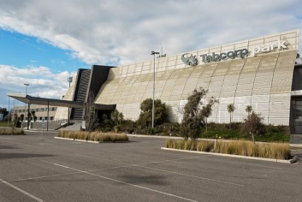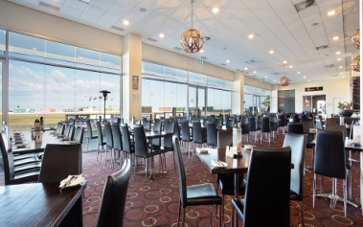

Turn RIGHT onto FERRIS ROAD towards Gisborne.

- The traditional owners of the land on which the City of Melton spans are the Wurundjeri and Wathaurong people. Wurundjeri country includes all land east of the Werribee River to the Melton LGA boundary.

- Melton is known as “Thoroughbred Country” because of the large number of harness racing and thoroughbred breeding and training stud farms and equestrian riding academies/schools.
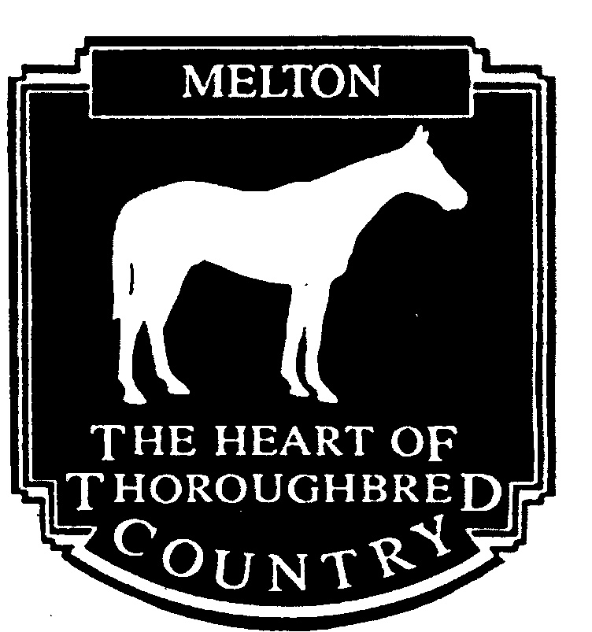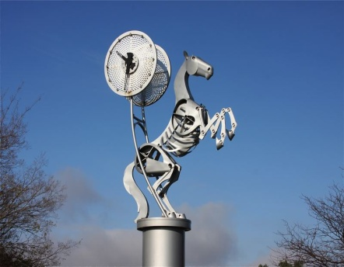

Continue on Ferris Rd. At the roundabout take the 2nd exit.

Continue ahead. At the next roundabout take the 1st exit, ie. turn left, onto FEDERATION ROAD.
Continue ahead. At the roundabout take the 2nd exit and continue on Federation Road.

- To the left is Melton Golf Course

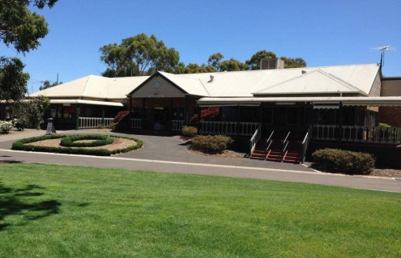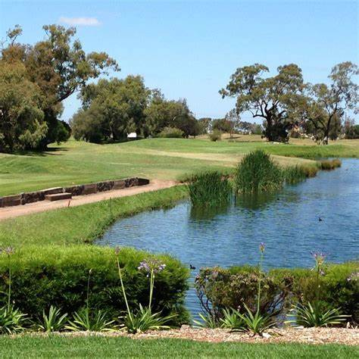

At the next roundabout take the 2nd exit onto MELTON-GISBORNE ROAD.

Continue on Melton- Gisborne Road for 7 Kms to TOOLERN VALE.

- On the left as you leave the built up area is the “JurAvon Park Equestrian Centre” where they train horses and riders in all aspects of competition (show jumping etc) including to Olympics standard.

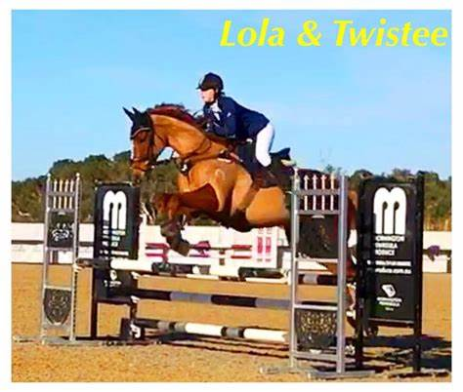

At the Toolern Vale roundabout turn LEFT onto COIMADAI ROAD and continue for 13 Kms.

- All along Coimadai Rd on both sides there are thoroughbred stud farms and equestrian riding schools. Some provide riding for the disabled too. Others have held concerts with chamber orchestras and opera singers – very popular.

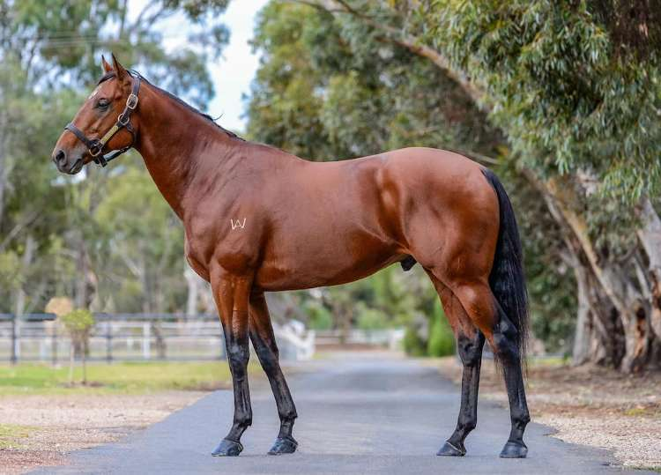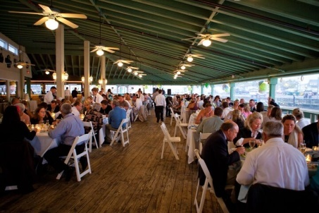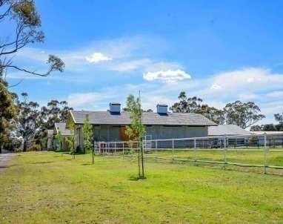

- Near the end of Coimadai Rd on the RHS is Lake Merrimu or Merrimu Reservoir. It was the main water supply to Bacchus Marsh and surrounding areas.

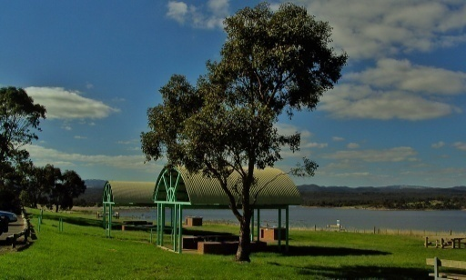

At the T intersection turn LEFT onto BACCHUS MARSH – GISBORNE ROAD

- Bacchus Marsh was NOT named after the Roman God of Wine as many people think.It was named after one of its original inhabitants, Captain William Henry Bacchus, who saw the great value of this locality as it was situated on two rivers — the Lerderderg and Werribee Rivers.....I rather like the wrong answer, don’t you? Bacchus Marsh is on the border between the Woiwurrung and Wathaurong territories of the Kulin Nation.

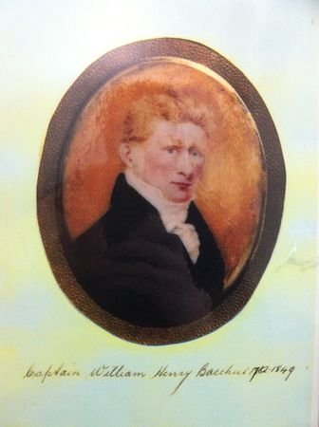

- Directly ahead is Lerderderg National Park which includes Wombat State Forest, which extends as far north as Gisborne.

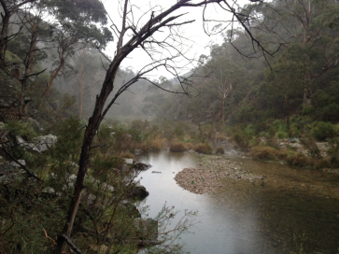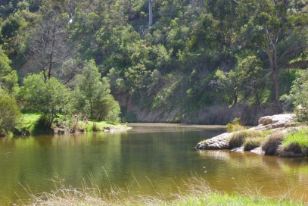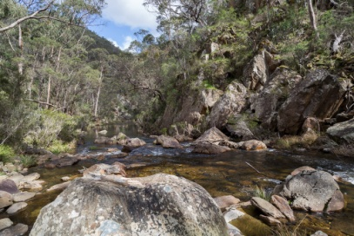

Continue on Bacchus Marsh – Gisborne Rd towards Bacchus Marsh for 4 Kms.

At the roundabout take the 3rd exit ie turn RIGHT onto GREY STREET. Continue on Grey St.

At the roundabout take the 1st exit ie turn LEFT onto HALLETTS WAY. Continue on Hallets Way.

At the roundabout take the 2nd exit and continue on Halletts Way.

At the next roundabout take the 3rd exit ie turn RIGHT onto BACCHUS MARSH ROAD and continue.

At the next roundabout take the 2nd exit, keep LEFT and take the on ramp onto the WESTERN HIGHWAY, towards Ballarat.

Continue 2 Kms keeping left to the first off ramp to PENTLAND HILLS and take the turn off.

At the T intersection turn RIGHT onto SUNNY HOLLOW LANE

At the 1st intersection turn LEFT onto PENTLAND HILLS ROAD (which becomes the Old Western Highway). Continue 7 Kms to MYRNIONG.

- The celebrated “ Plough Myrniong” gastropub (terrible term!) is on the left.

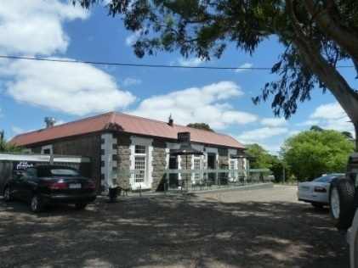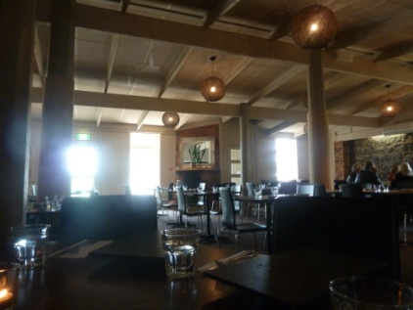

Continue for 2 Kms on the Old Western Hwy to the
GREENDALE – MYRNIONG ROAD intersection.

Turn LEFT then turn RIGHT onto the WESTERN HIGHWAY, towards Ballarat.

Continue on the Western Hwy for 5 Kms. Keep left and take the BALLAN turn off onto the OLD MELBOURNE ROAD.

Continue 4.5 Kms, through Ballan to the Old Melbourne Road – Geelong Ballan Road intersection. Turn LEFT towards Geelong and continue for 2.5 Kms.

Turn RIGHT onto Mt. EGERTON ROAD and continue for 9 Kms.

At the T intersection turn RIGHT onto MAIN ROAD which becomes GORDON – EGERTON ROAD and continue for 5.5 Kms to GORDON.

At the T intersection turn LEFT onto Main/Old Melbourne Road

- At the intersection on the left is “Gordon’s at Gordon” (excellent food and coffee) formerly “Gordon Bleu” until “Cordon Bleu Cooking School” took offence and felt that people would get confused (???). The building was once a convent and Mother Teresa stayed there.

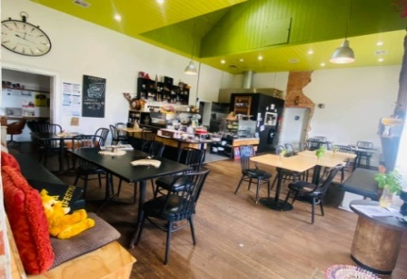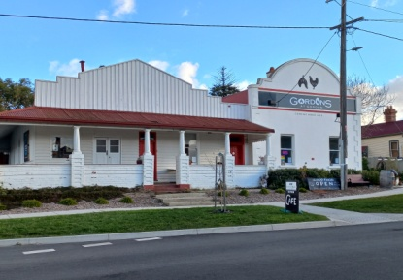

- Further up the road on the left at the next intersection is a must see millinery “Gordon Hat Shoppe”, with a massive range of hats for both men and women. Next to it, across the road is “the Shambles” – boots galore!

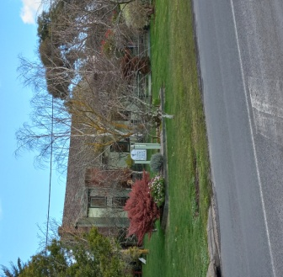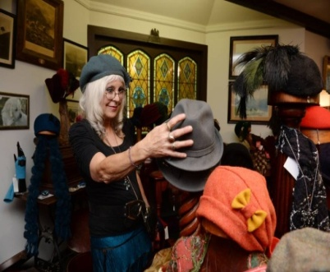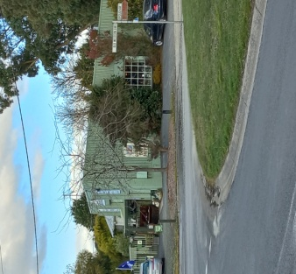

Continue straight ahead on Old Melbourne Road for 5.5 Kms.

Turn RIGHT onto WESTCOTTS ROAD (we’ll have a sign so you can’t miss the turn off) and continue for 4 Kms to WALLACE.

At the BUNGAREE – WALLACE ROAD intersection the WALLACE HOTEL is right in front of you..... you can’t miss it.

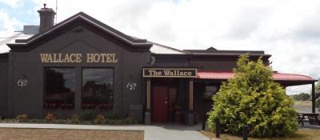

ENJOY YOUR LUNCH.

HOPE YOU ENJOYED THE DRIVE!

